# Department of Computing

**CS-213: Advanced Programming**

**Class: BSCS 7AB**

# Lab 07: Express JS

**Date: 17 October, 2019**

**Time: 10:00-01:00pm & 02:00-05:00pm**

# Name:Tatheer Zahra

# Class: CS-7A

# Reg#211972

# Lab 07: Express JS

**Lab Tasks**

**Task 1:**

**Code:**

**Server:**

var express = require('express');

var bodyParser = require('body-parser');

var multer = require('multer');

var upload = multer();

var app = express();

app.use(bodyParser.json());

app.use(bodyParser.urlencoded({ extended: true }));

app.use(express.static('public'));

app.post('localhost:3000/serverwali.js', function(req, res){

console.log(req.body);

res.send("recieved your request!"); });

app.listen(3000);

**HTML FILE:**

<!DOCTYPE html>

<html>

<head>

<title> HEY</title>

</head>

<body>

<form action = "localhost:3000/serverwali.js" method = "post">

Name: <input type = "text" name = "name"></br></br>

Degree: <input type = "text" name = "degree"></br></br>

Class: <input type = "text" name = "class1"></br></br>

<button type = "submit" name = "button">Submit</button>

</form>

</body>

</html>

**OUTPUT:**

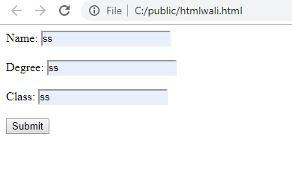

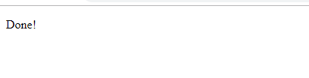

**Task 2:** Create a file uploader form in an html file. This form has method attribute set to POST and enctype attribute is set to multipart/form-data. Modify server.js to handle home page requests as well as file upload.

**CODE:**

**HTML:**

<!DOCTYPE html>

<html>

<head>

<title> HEY</title>

</head>

<body>

<form action = "http://127.0.0.1:8081/process" method = "post" enctype = “multipart/form-data”>

FILE: <input type = "file" name = "file"></br>

<button type = "submit" name = "button">Upload File</button>

</form>

</body>

</html>

**SERVER:**

var express = require("express");

var multer = require('multer');

var app = express();

var storage = multer.diskStorage({

destination: function (req, file, callback) {

callback(null, './uploads');

},

filename: function (req, file, callback) {

callback(null, file.originalname);

}

});

var upload = multer({ storage : storage}).single('myfile');

app.get('/',function(req,res){

res.sendFile(__dirname + "/htmlwali.html");

});

app.post('/',function(req,res){

upload(req,res,function(err) {

res.end("Done!");

});

});

app.listen(2000,function(){

console.log("Successful!");

});

**OUTPUT:**

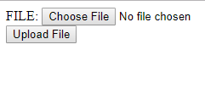



**Task 3:** By using the Pug templating engine create an HTML registration form.

CODE:

PUG:

html

head

title Hey

body

form(action = "/", method = "POST")

div

label(for = "Name") Name:

input(name = "name1" value = "Tat")

br

div

label(for = "Class") Class:

input(name = "c1" value = "c12")

br

button(type = "submit") Submit

SERVER:

var express = require('express');

var bodyParser = require('body-parser');

var multer = require('multer');

var upload = multer();

var app = express();

app.set('view engine', 'pug');

app.set('views', './views');

app.get('/', function(req, res){

res.render('form');

});

app.use(bodyParser.json());

app.use(bodyParser.urlencoded({ extended: true }));

app.use(upload.array());

app.use(express.static('public'));

app.post('/', function(req, res){

console.log(req.body);

res.send("Done!");

});

app.listen(3000);

OUTPUT

